# Market Direction

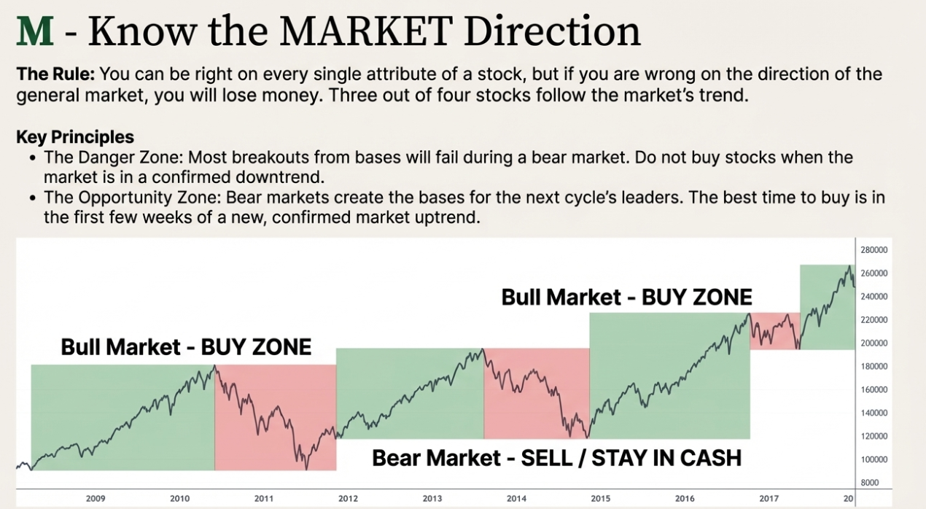

Slide Deck: M = Market Direction: How You Can Determine It (Chapter 9)

Slide 1: Introduction – The Critical Importance of Market Direction

* The ability to accurately determine the **direction of the general market** is an absolutely essential tool in your analytical kit.
* If you are wrong about the market direction, especially if the direction is down, **three out of four of your stocks will plummet** along with the market averages, potentially leading to big losses.
* The goal is to learn a proven, reliable method to accurately determine whether the market is a **bull (uptrending) market or a bear (downtrending) market**.
* Don't ever let anyone tell you that you can't time the market; this is a giant myth passed on by those who have never been able to do it.

Slide 2: Primary Tool – Analyzing Key Market Averages

* The best way to determine the direction of the market is to **look carefully at, follow, interpret, and understand the daily charts** of the three or four major general market averages.
* Key indexes include the **S&P 500**, the **Nasdaq Composite** (more volatile and relevant in recent years), and the **Dow Jones Industrial Average (DJIA)**.
* **Market as a Leading Indicator:** The stock market is a leading economic indicator.
* Bear markets usually end while business is still in a downturn, as stocks anticipate future events.
* Bull markets usually top out and turn down *before* a recession sets in.
* You must check the general market averages **every day**, since reverses in trends can begin on any given few days.

Slide 3: Stages of a Normal Stock Market Cycle

* Most bull (up) markets historically last **two to four years** and are followed by a recession or a bear (down) market,.
* In the **beginning phase of a new bull market**, growth stocks are usually the first to lead and make new price highs.
* The really **big money is usually made in the first one or two years** of a normal new bull market cycle.
* Stock opening/closing behavior often provides clues:
* In **bear markets**, stocks usually open strong and **close weak**.
* In **bull markets**, they tend to open weak and **close strong**.

Slide 4: Identifying Market Tops (The Distribution Phase)

* A market top is detected by observing **distribution days** (professional selling) in the major market averages.
* **Key Signal: Heavy Volume Without Further Price Progress Up**On an uptrend day, volume for the market as a whole increases from the day before, but the index itself shows **stalling action** (a significantly smaller price increase for the day compared with the prior day’s price increase).
* The market index does not necessarily have to close down, but often it will, making the distribution easier to see.
* For a decline to count as distribution, the index must decline **more than 0.2%** on volume larger than the prior day's volume.
* **The Rule:** Normal liquidation near the market peak will occur on **three to five specific days over a period of four or five weeks**. After four or five days of definite distribution, the general market will **almost always turn down**.
* *Example:* The top in late 2007 included seven crucial warning days from October 3rd through November 1st,.

Slide 5: Secondary Indicators of a Market Top

* **Action of Leaders:** After the market has advanced for a couple of years, be cautious if most individual stock leaders start acting abnormally.
* They may break out of third- or fourth-stage chart base formations that appear faulty, **wider, and looser**,.
* They may display a **"climax" top**, running up more rapidly for two or three weeks in a row.
* Leading stocks that seem to be holding up will eventually succumb to the selling if the market is in a bear trend.
* **Laggards Strengthening:** The sight of sluggish, low-priced, or lower-quality laggard stocks strengthening is a signal that the up market **may be near its end**,.
* **Divergence of Averages:** Check if key averages are moving in different directions (one up and one down) or if one index is advancing at a much slower rate than another. The **broader-based S&P 500 failing to hit a new high** when the Dow does is a key divergence signal.

Slide 6: Identifying Market Bottoms

* **Rally Attempt:** A rally attempt begins when a major market average **closes higher** after a decline.
* **Wait for Confirmation:** Sit tight and be patient; the first few days of improvement cannot confirm if the rally will succeed.
* **The Follow-Through Day Rule:**Starting on the **fourth day** of the attempted rally, look for one of the major averages to **“follow through”** with a booming gain on **heavier volume** than the day before.
* The most powerful follow-throughs usually occur on the **fourth to seventh days** of the rally.
* A follow-through day should feel **explosive, strong, decisive, and conclusive**.
* **Warning: Rally Failures:** Initial bounce backs are feeble if the index advances on lower volume, makes little price progress, or recovers less than half of the initial drop.

Slide 7: Action Required – Protection and Preservation

* **The Key to Success:** It is not predicting or knowing what the market is going to do; it is **knowing and understanding what the market has actually done** in the past several weeks and what it is currently doing *now*.
* **Protect Your Capital:** When market indexes peak and begin major downside reversals, you should **act immediately**.
* Put **25% or more of your portfolio in cash**.
* Get **off margin** (borrowed money) immediately,,.
* Use the 7% or 8% loss-cutting rule—this will mechanically force you out of many stocks as a correction develops,.
* Learning this historically proven method should prevent finding your portfolio down 30% to 50% or more in a bad bear market.

----------------------------------------------------------------------------------------

The letter **M** in the CAN SLIM investment system stands for **Market Direction**, which is described as the **overriding factor** in successful stock investing,.

The sources emphasize that the ability to accurately determine the direction of the general market is an **absolutely essential tool** in an investor's analytical kit. The rationale for this necessity is critical: if an investor is wrong about the market direction, especially if the direction is down, **three out of four of their stocks will plummet** along with the market averages, potentially leading to big losses. Therefore, mastering this principle is key to avoiding finding an investment portfolio **down 30% to 50% or more in a bad bear market**.

Determining Market Direction: The Core Method

The proven, reliable method for determining whether the market is a bull (uptrending) or bear (downtrending) market involves constantly observing and analyzing major indexes,. The objective is to stop arguing with the market and instead concentrate on **knowing and understanding what the market has actually done in the past several weeks and what it is currently doing now**.

Key components of this analysis include:

1. **Analyzing Key Averages:** Investors must look carefully at, follow, interpret, and understand the **daily charts** of the major general market averages. The most common indexes to track are the **S&P 500, the Nasdaq Composite**, and the **Dow Jones Industrial Average (DJIA)**. These averages must be checked **every day** since reverses in trends can begin rapidly,.
2. **Market as a Leading Indicator:** The stock market is a **leading economic indicator**, anticipating events many months in advance. **Bear markets usually end while business is still in a downturn**, and, similarly, **bull markets usually top out and turn down before a recession sets in**,,. Investors should not rely on traditional economic indicators to determine when to buy or sell stocks.
3. **Behavioral Clues:** In **bear markets**, stocks usually open strong and **close weak**, while in **bull markets**, they tend to open weak and **close strong**,.

Identifying Market Tops (Distribution)

Market tops are detected by watching for signals of **distribution** (professional selling) in the major market averages. Distribution occurs when an index shows signs of stalling action, indicating professional investors are liquidating stock while the market is still advancing,.

A distribution day is counted when:

* The volume for the market as a whole **increases from the day before**, but the index itself shows **stalling action** (a significantly smaller price increase for the day compared with the prior day’s price increase).
* The index must decline **more than 0.2%** on volume larger than the prior day's volume for the decline to count as distribution.

Normal liquidation near the market peak typically occurs on **three to five specific days over a period of four or five weeks**. After four or five days of definite distribution, the **general market will almost always turn down**.

Identifying Market Bottoms (Follow-Through)

When the market declines, the investor must wait patiently for confirmation of a new uptrend,.

1. **Rally Attempt:** A rally attempt begins when a major market average **closes higher** after a decline,.
2. **Follow-Through Day:** Starting on the **fourth day** of the attempted rally, investors must look for one of the major averages to **“follow through” with a booming gain on heavier volume** than the day before,. The most powerful follow-throughs usually occur between the **fourth to seventh days** of the rally,.
3. **Confirmation:** A follow-through day is vital because **no new bull market has ever started without a strong price and volume follow-through confirmation**,.

In the larger context of the CAN SLIM strategy, recognizing market direction (M) informs the timing of purchases (N) and sales (Part II), ensuring that the investor buys leading stocks (L) only when the overall market environment is favorable. Furthermore, following the selling rules in conjunction with market direction indicators will mechanically force an investor out of many stocks as a correction develops, preserving capital,.

----------------------------------------------------------------------------------------

The letter **M** in the CAN SLIM investment system represents **Market Direction**. The sources emphasize that M is the **overriding factor** in successful stock investing and is **absolutely essential** to the investor’s analytical toolkit.

The critical importance of correctly determining the market's direction lies in risk management and capital preservation. If an investor is **wrong about the direction of the general market, and that direction is down, three out of four of their stocks will plummet** along with the market averages, potentially leading to big losses. Learning a proven, reliable method for timing is intended to prevent finding an investment portfolio **down 30% to 50% or more in a bad bear market**.

The core objective is not predicting the future, but rather knowing and understanding **what the market has actually done in the past several weeks and what it is currently doing now**.

Determining Market Direction

The primary way to determine the market direction is to **look carefully at, follow, interpret, and understand the daily charts of the three or four major general market averages**. The key indexes tracked include the **S&P 500, the Nasdaq Composite, and the Dow Jones Industrial Average (DJIA)**.

Key considerations in this process include:

* **Leading Indicator Status:** The stock market acts as a **leading economic indicator**, anticipating (or "discounting") future economic, political, and worldwide events months in advance. Consequently, using traditional economic indicators is **not recommended** for determining when to buy or sell stocks.
* **Behavioral Clues:** Stocks generally provide behavioral clues about the market trend. In **bear markets, stocks usually open strong and close weak**. Conversely, in **bull markets, they tend to open weak and close strong**.
* **Cycles:** Most bull markets typically last **two to four years** and are followed by a bear market. The really **big money is usually made in the first one or two years** of a new bull market cycle.

Identifying Market Tops (Distribution)

A market top is signaled by evidence of **distribution days**—periods of professional selling. Liquidation typically occurs while the market indexes are still advancing.

The specific warning signals include:

* **Heavy Volume Without Further Price Progress Up:** A major average shows **stalling action** (a significantly smaller price increase for the day compared with the prior day's increase) while volume for the market as a whole **increases from the day before**.
* **Distribution Day Confirmation:** For a decline to count as a distribution day, the index must decline **more than 0.2%** on volume larger than the prior day's volume.
* **The Rule:** Normal liquidation near the market peak occurs on **three to five specific days over a period of four or five weeks**. After four or five days of definite distribution, the general market **will almost always turn down**.
* **Secondary Warnings:** Investors should be cautious if **most individual stock leaders start acting abnormally** (e.g., breaking out of faulty, wider, and looser third- or fourth-stage base formations). Additionally, the strengthening of **sluggish, low-priced, or lower-quality laggard stocks** is a signal that the uptrend may be nearing its end. Divergence, such as the broader **S&P 500 failing to hit a new high** when the Dow Jones Industrials does, is also a key signal.

Identifying Market Bottoms (Follow-Through)

When the market declines, investors must wait for definite confirmation before buying again:

1. **Rally Attempt:** A rally attempt begins when a major market average **closes higher** after a decline.
2. **Follow-Through Day:** Starting on the **fourth day** of the attempted rally, look for one of the major averages to **“follow through” with a booming gain on heavier volume** than the day before. The most powerful follow-throughs usually occur on the **fourth to seventh days** of the rally.
3. **Confirmation:** **No new bull market has ever started without a strong price and volume follow-through confirmation**. This signal gives the investor the go-ahead to begin buying.

M in the Context of CAN SLIM Strategy

Integrating market direction (M) into the overall CAN SLIM strategy dictates the timing of buying and selling:

* **Protection (Selling):** When market indexes peak and major downside reversals begin, the investor must **act immediately**. This includes putting **25% or more of the portfolio in cash** and getting **off margin** (borrowed money) immediately. Furthermore, using the strict 7% or 8% loss-cutting rule will **mechanically force** the investor out of many stocks as a market correction develops.
* **Opportunity (Buying):** Once a new uptrend is confirmed by a follow-through day, the investor should focus on purchasing the highest-quality stocks (L) that are emerging from sound base patterns (N) and displaying high trading volume (S), thereby ensuring that purchases are made when the overall market environment is favorable.

**Briefing on Investment Strategies and Market Analysis**

**Executive Summary**

This document synthesizes a comprehensive investment methodology centered on the CAN SLIM system, a strategy derived from an exhaustive historical analysis of the greatest-performing stocks in the U.S. market since the 1880s. The core philosophy posits that by studying the common characteristics of past market leaders immediately prior to their major price advances, investors can develop a robust framework for identifying future winners.

The methodology heavily emphasizes a dual approach of strong fundamental analysis and precise technical analysis. Key fundamental criteria include substantial and accelerating quarterly and annual earnings growth, high return on equity, and significant sales growth, often driven by innovative new products or services. Technical analysis, primarily through the interpretation of stock charts, is deemed indispensable for timing purchases and sales. Recognizable price patterns, or "bases," such as the "cup with handle," signal periods of institutional accumulation and provide optimal buy points.

Crucially, the strategy insists on buying market leaders—stocks outperforming the vast majority of others—and avoiding laggards or "sympathy plays." It also underscores the importance of institutional sponsorship as a key source of demand, while warning against stocks that become "overowned." Determining the overall market direction is considered paramount, as three out of four stocks follow the general trend.

Perhaps the most critical component of the system is its disciplined approach to selling. The cardinal rule is to cut every loss at a maximum of 7-8% without exception to protect capital. Conversely, profitable positions should be allowed to grow, with selling decisions based on specific technical signals of price tops, rather than arbitrary profit targets or fundamental news that often lags market action. This disciplined risk management is presented as the cornerstone of long-term success, enabling investors to profit even if they are correct on less than half of their stock selections.

--------------------------------------------------------------------------------

**I. The Core Philosophy: Learning from Market History**

The investment strategy is built upon the foundational principle that "history repeats itself" in the stock market. This is attributed to the unchanging nature of human psychology and the fundamental law of supply and demand. The first step for any investor is to study the characteristics of past market leaders to build a model for future success.

**The Model Book of Greatest Stock Market Winners**

A comprehensive historical study was conducted, analyzing over 1,000 of the biggest winning companies in the U.S. stock market over 125 years, from the 1880s to 2008. This study, referred to as "The Model Book of Greatest Stock Market Winners," identified a set of common traits shared by these "super stocks" just before they made their most significant price advances.

* **Key Insight:** "The first step in learning how to pick big stock market winners is to examine leaders of the past... to learn the characteristics of the most successful stocks."

Examples of companies analyzed in this study include:

* **Texas Instruments:** Soared from $25 to $250 (January 1958 - May 1960).
* **Xerox:** Escalated from $160 to an equivalent of $1,340 (March 1963 - June 1966).
* **Syntex:** Leaped from $100 to $570 in six months (latter half of 1963).
* **Cisco Systems:** Advanced from a split-adjusted $0.10 to $82 (October 1990 - March 2000).
* **Home Depot:** Jumped 20-fold in less than two years from its 1981 IPO and another 10 times from 1988 to 1992.

**The CAN SLIM Framework**

The study distilled seven common characteristics of winning stocks into the acronym **CAN SLIM**. This system is not based on personal opinion or academic theory but on a pragmatic analysis of how the market actually operates. A successful investment approach combines identifying stocks with strong fundamentals (big increases in sales, earnings, and return on equity) with the ability to read chart patterns that reveal institutional buying.

**II. The Indispensable Role of Chart Analysis**

Stock charts are presented as a critical and non-negotiable tool for any serious investor, analogous to the diagnostic tools used by doctors (X-rays, CAT scans) or a road map for a driver. They record a stock's price and volume history, helping to determine if a stock is healthy and under accumulation (buying) or weak and behaving abnormally.

* **Core Tenet:** Buying or selling stocks without consulting charts is "just plain foolish." Charts provide a "gold mine of information" for evaluating current conditions and improving timing.
* **Formation of Bases:** Chart patterns, or "bases," are areas of price correction and consolidation that occur after a price advance. Approximately 80% to 90% of these patterns are formed as a result of corrections in the general market. The key skill is to diagnose whether the price and volume movements within these bases are normal (signaling strength) or abnormal (signaling weakness).

**Recognizable Price Patterns of Winning Stocks**

The historical analysis identified several recurring, successful price patterns that serve as models for future selections.

|  |  |  |
| --- | --- | --- |
| Pattern Type | Description | Key Characteristics |
| **Cup with Handle** | The most common and classic pattern, resembling a cup with a handle when viewed from the side. | Base forms after a prior uptrend. The "cup" is a period of price correction, followed by a smaller, downward-drifting "handle" consolidation. Minimum base length is typically 7-8 weeks. |
| **Saucer with Handle** | Similar to the cup with handle, but the "saucer" portion is shallower and stretches over a longer period. | Example: Jack Eckerd in April 1967. |
| **Double Bottom** | A pattern that looks like the letter "W," with two distinct price troughs. | The second low point should undercut the first, shaking out weaker holders. The middle peak of the "W" is a key resistance level. |
| **Flat Base** | Occurs after a stock breaks out of an initial base and advances. It moves sideways in a narrow price range. | Typically lasts at least 5-6 weeks. Corrects no more than 10-15%. Offers a second buying opportunity. |
| **Square Box** | A newer classification, this formation has a square, boxy look and forms after an initial advance. | Lasts 4-7 weeks. Price correction is typically only 10-15%. |
| **High, Tight Flag** | A rare, powerful, but very risky pattern. | Begins with a stock moving up 100% to 120% in a very short period (4-8 weeks). It then corrects sideways no more than 10-25% over 3-5 weeks. Can lead to 200%+ moves. |
| **Base on Top of a Base** | Forms during the latter stages of a bear market. A stock breaks out but is pulled back by the weak market, forming a second consolidation area on top of its first base. | These stocks are often among the first to emerge as new leaders when a bull market begins. |
| **Ascending Base** | A series of three small pullbacks, each with a slightly higher low and higher high. | Occurs midway through a stock's overall advance. |

**Identifying and Avoiding Faulty Patterns**

Not all patterns are reliable. Recognizing faulty structures is crucial to avoid failed breakouts.

* **Wide-and-Loose Structures:** These erratic patterns are failure-prone. They often feature excessive price declines (e.g., over 40%) and take too long to form a bottom. Sometimes, a stock will "tighten up" and form a more constructive base after an initial wide-and-loose period. Examples of stocks that eventually tightened up include New England Nuclear and Houston Oil & Minerals.
* **Unreliable Patterns:** The analysis found patterns like triangles, coils, and pennants to be unreliable and risky, often lacking sufficient time or price correction to form a proper base. Triple bottoms and head-and-shoulders bottoms are also considered weaker patterns for buying, though a head-and-shoulders *top* can be a reliable sell signal.
* **Minimum Base Length:** With few exceptions (like flat bases or high, tight flags), the most reliable base patterns require a minimum of seven to eight weeks of price consolidation.

**Key Chart Interpretation Techniques**

* **Pivot Buy Points:** The optimal purchase point is not typically at the stock's old absolute high price. Most pivots occur 5% to 10% *below* the prior peak, usually as the stock breaks out of the "handle" area or a consolidation pattern.
* **Volume Clues:** Big daily and weekly volume spikes are valuable signals. A breakout on volume that is significantly above average (e.g., 545% above average for Microsoft) signals important institutional buying. An "extreme volume dry-up" during a price consolidation is also a very constructive sign.
* **Overhead Supply:** This is a critical concept referring to areas of price resistance created by investors who previously bought at higher levels. These investors are often motivated to sell when the price returns to their break-even point, frustrating upward movement. Stocks breaking out into new all-time high ground have no overhead supply, which adds to their appeal.
* **Relative Price Strength (RS):** The RS line on a chart plots a stock's price performance against a market index like the S&P 500. A rising RS line indicates the stock is outperforming the market. A declining RS line for seven months or more is a highly questionable sign.

**III. The CAN SLIM Method: A Framework for Stock Selection**

CAN SLIM is the acronym summarizing the seven key traits of past market leaders.

**C = Current Big or Accelerating Quarterly Earnings Per Share**

The "single most important element in stock selection" is a company's percentage change in quarterly Earnings Per Share (EPS).

* **Rule:** Look for significant increases, with a minimum of 25-30%. In bull markets, the best stocks often show gains of 40% to 500% or more.
* **Examples:**
  + **Dell:** EPS surged 74% and 108% in the two quarters before its major run-up from November 1996.
  + **Cisco:** Posted earnings gains of 150% and 155% before its run-up from October 1990.
  + **AOL:** Earnings were up 900% and 283% before its burst from October 1998.
  + **Apple:** Earnings were up 350% before it took off, with the next quarter up another 300%.

**A = Annual Earnings Growth**

Strong annual growth is also essential, demonstrating a consistent track record.

* **Rule:** Look for companies that have shown annual EPS growth of at least 25% for each of the last three years.

**N = New Products, New Management, New Highs**

The greatest stock market winners are often driven by innovation and change.

* **New Products or Services:** Companies that achieve enormous success often introduce revolutionary products that change how people live. Over 95% of successful stocks from 1880 to 2008 were tied to new products, new industries, or new market conditions. (See Appendix B for a detailed list).
* **New Management:** A change in leadership can reinvigorate a company.
* **New Highs:** This component introduces the **"Great Paradox"** of the stock market: *What seems too high in price and risky to the majority usually goes higher eventually, and what seems low and cheap usually goes lower.* Studies show that stocks making new price highs tend to continue higher, while those making new lows tend to continue lower. The job of the investor is to buy when a stock looks too high to the majority as it emerges from a sound price base.

**S = Supply and Demand**

The law of supply and demand governs stock prices.

* **Number of Shares:** Stocks with a smaller number of shares outstanding (e.g., 50 million) require less demand to move the price up compared to giants with billions of shares.
* **Management Ownership:** Companies where top management owns a significant percentage of the stock (1-3% in a large company, more in smaller ones) are generally better prospects.
* **Stock Buybacks:** A company buying back its own stock is usually a positive sign, as it reduces the supply of shares and can increase EPS. A 10% buyback is considered large.
* **Stock Splits:** While often viewed positively, a stock frequently reaches its price top around its second or third split. Only 18% of big winners had splits in the year preceding their major price advance.

**L = Leader or Laggard**

Investment should be confined to market leaders.

* **Identify the Leader:** The true leader is the company with the best fundamental metrics (earnings, sales, ROE, margins) and the most dynamic stock price action in its industry group.
* **Avoid Sympathy Plays:** A sympathy play is a second-rate stock in the same industry as a strong leader. These stocks look "cheaper" but their performance almost always pales in comparison. As Andrew Carnegie said, "The first man gets the oyster; the second, the shell."
* **Relative Strength (RS) Rating:** An easy way to separate leaders from laggards is by checking the stock's RS Rating (found in *Investor's Business Daily*). This proprietary rating measures a stock's price performance over the past 52 weeks on a scale of 1 to 99.
  + **Rule:** The average RS Rating of the best-performing stocks *before* their major run-ups was 87. Investors should focus on stocks with RS Ratings of 85 or higher and avoid those below 70.

**I = Institutional Sponsorship**

Institutional investors (mutual funds, pension funds, etc.) are the biggest source of demand and account for the lion's share of market activity.

* **Requirement:** A winning stock needs at least a few institutional owners; twenty is a reasonable minimum for smaller companies. The number of sponsors should be increasing in recent quarters.
* **Quality over Quantity:** It is also important to identify *who* the sponsors are. Ownership by one or two of the better-performing, well-managed funds is a major positive.
* **The Risk of Being "Overowned":** A stock can have too much institutional ownership. When performance is so obvious that almost every institution owns it, the stock is likely near its peak. This excessive ownership creates a large potential for selling if something goes wrong. Examples of overowned stocks at their peaks include Cisco (2001), AIG (2008), and Citigroup (2008).

**M = Market Direction**

Recognizing the overall market trend is 50% of the investment challenge.

* **Rule:** Three out of four stocks will follow the general market's direction. It is critical to learn how to determine if the market is in a confirmed uptrend (bull market) or a correction/downtrend (bear market).
* **Identifying a Market Top:** A topping process is signaled by **distribution**. A distribution day is when a major market index (e.g., S&P 500, Nasdaq) closes down for the day on volume that is higher than the previous day's volume. Five or six distribution days over a four or five-week period is a major red flag, indicating it is time to sell stocks and raise cash.
* **Identifying a Market Bottom:** A new bull market is often signaled by a **follow-through day**. This occurs on the fourth day or later of an attempted market rally (after a low point) when a major index closes up significantly (e.g., 1.7% or more) on higher volume than the day before.
* **Warning:** Investors should **absolutely not buy breakouts during a bear market**, as most of them will fail.

**IV. The Art of Selling and Portfolio Management**

Knowing when to sell is as important, if not more important, than knowing when to buy. A disciplined selling strategy is essential for protecting capital and locking in profits.

**The Cardinal Rules of Selling**

1. **Cut All Losses at 7% to 8%:** This is the most important rule. An investor must always cut losses short, without exception. This prevents small, manageable losses from turning into catastrophic ones. If a stock bought at a correct pivot point drops 8%, it signifies either the selection was wrong or the general market is turning negative.
2. **Sell to Take Profits:** The objective is to make big gains when you are right. A general rule is to aim for a 20-25% profit on a stock. However, if a stock runs up 20% in less than three weeks from a proper breakout, it is a sign of exceptional strength and should be held for at least eight weeks. The biggest winners often require holding for six months to a year or more. Bernard Baruch stated, "I have sold a stock while it was still rising—and that has been one reason why I have held on to my fortune."
3. **Recognize Technical Sell Signs:** Many stocks top when their earnings are still strong and analysts are bullish. Therefore, selling decisions must often be based on technical price and volume action. A primary sell signal is a **climax top**, where a stock, after a long advance, suddenly accelerates upward at a much faster rate for one or two weeks on heavy volume. This is often a sign of exhaustion and a final burst of buying before institutions begin to sell heavily.

**Portfolio Management Strategy**

* **Avoid Over-diversification:** Wide diversification is described as "a substitute for lack of knowledge" and "a hedge for ignorance." The best results are achieved through concentration.
  + **$5,000 - $20,000 portfolio:** 2-3 stocks maximum.
  + **$20,000 - $100,000 portfolio:** 4-5 stocks maximum.
  + **Over $1,000,000 portfolio:** 6-7 stocks maximum.
* **The "Long Haul" Fallacy:** The holding period should not be predetermined. It is dictated by the stock's performance and the market's direction. Losers should be held for very short periods, while winners can be held for months or years. A well-run portfolio should never have a loss carried for six months or more.
* **Averaging Up vs. Averaging Down:** A common mistake is "averaging down"—buying more of a stock as its price falls. The correct approach is to "average up" (or pyramid), making one or two smaller additional purchases after an initial buy proves successful (i.e., the stock advances 2-3% from the pivot point).

**V. Common Investor Mistakes to Avoid**

The source context identifies 19 classic mistakes made by most investors.

|  |  |
| --- | --- |
| Mistake # | Description |
| 1 | Holding on to losses and hoping they will come back. |
| 2 | Buying a stock on the way down because it seems like a bargain. |
| 3 | Averaging down in price instead of averaging up. |
| 4 | Buying large amounts of a low-priced stock instead of a smaller number of shares of a higher-priced, higher-quality stock. |
| 5 | Wanting to make a quick, easy buck without doing the necessary research. |
| 6 | Buying based on tips, rumors, news, or advisory service recommendations. |
| 7 | Selecting second-rate stocks because of high dividends or a low Price/Earnings (P/E) ratio. |
| 8 | Buying familiar "old names" instead of newer, more dynamic companies. |
| 9 | Not being able to recognize and follow good information and sound advice. |
| 10 | Being afraid to buy stocks making a new price high. |
| 11 | Cashing in small profits while letting losses run. |
| 12 | Worrying excessively about taxes and commissions. |
| 13 | Speculating too heavily in options and futures. |
| 14 | Using price limits on buy and sell orders, often missing the market. |
| 15 | Hesitating and failing to make a decision when the time is right. |
| 16 | Not having a clear understanding of what to look for in a successful company. |
| 17 | Not having specific rules for timing the general market. |
| 18 | Not using charts to improve stock selection and timing. |
| 19 | Lacking clear rules for buying and selling and being guided by personal opinions and emotions. |

--------------------------------------------------------------------------------

**Appendix A: Historical Performance of Winning Stocks (Selected Examples)**

The following table showcases a sample of the historical stock market winners analyzed, highlighting the magnitude and duration of their major price advances.

|  |  |  |
| --- | --- | --- |
| Company | Percentage Increase | Duration (Weeks) |
| Yahoo! | 6723% | 130 |
| TASER International | 2228% | 39 |
| Qualcomm | 2091% | 45 |
| Burroughs Adding Machines | 1992% | 168 |
| J D S Uniphase | 1946% | 66 |
| Cisco Systems | 1602% | 169 |
| Brunswick | 1500% | 162 |
| Bethlehem Steel | 1479% | 99 |
| Wang Laboratories | 1348% | 139 |
| Apple | 1418% | 199 |
| Ascend Communications | 1384% | 75 |
| Accustaff | 1359% | 68 |
| Northwest Airlines | 1240% | 186 |
| Xerox | 1201% | 188 |
| Northern Pacific | 1181% | 29 |
| Schenley Distilling | 1164% | 185 |
| Peoplesoft | 1145% | 129 |
| Du Pont de Nemours | 1074% | 225 |
| Loews | 1025% | 101 |
| National Airlines | 1004% | 179 |

**Appendix B: Examples of Companies Driven by Innovation**

The following is a list of 25 companies and the new products, services, or industry shifts that propelled their stock price to extraordinary gains, illustrating the "N" (New) in the CAN SLIM model.

|  |  |  |
| --- | --- | --- |
| # | Company | Innovation / New Product |
| 1 | Northern Pacific | First transcontinental railroad |
| 2 | General Motors | The automobile (via Buick Motor Co.) |
| 3 | RCA | Commercial radio |
| 4 | Rexall | Tupperware |
| 5 | Thiokol | New rocket fuels for missiles |
| 6 | Syntex | Oral contraceptive pill |
| 7 | McDonald’s | Low-priced fast-food franchising |
| 8 | Levitz Furniture | Giant warehouse discount-furniture centers |
| 9 | Houston Oil & Gas | Major new oil field |
| 10 | Computervision | CAD-CAM factory-automation equipment |
| 11 | Wang Labs | New word-processing office machines |
| 12 | Price Company | Innovative wholesale warehouse membership stores |
| 13 | Amgen | New biotech drugs (Epogen and Neupogen) |
| 14 | Cisco Systems | Routers and networking equipment for LANs |
| 15 | International Game Tech | New microprocessor-based gaming products |
| 16 | Microsoft | Windows software dominance |
| 17 | PeopleSoft | Number one maker of personnel software |
| 18 | Dell Computer | Build-to-order, direct PC sales |
| 19 | EMC | Superior computer memory/network storage devices |
| 20 | AOL and Yahoo! | Top Internet "portals" for consumers |
| 21 | Oracle | Database and e-business applications software |
| 22 | Charles Schwab | Number one online discount broker |
| 23 | Hansen Natural | "Monster" energy fruit drinks |
| 24 | Google | Instant information via the Internet |
| 25 | Apple | The iPod music player |

# Kristijan Qullamaggie



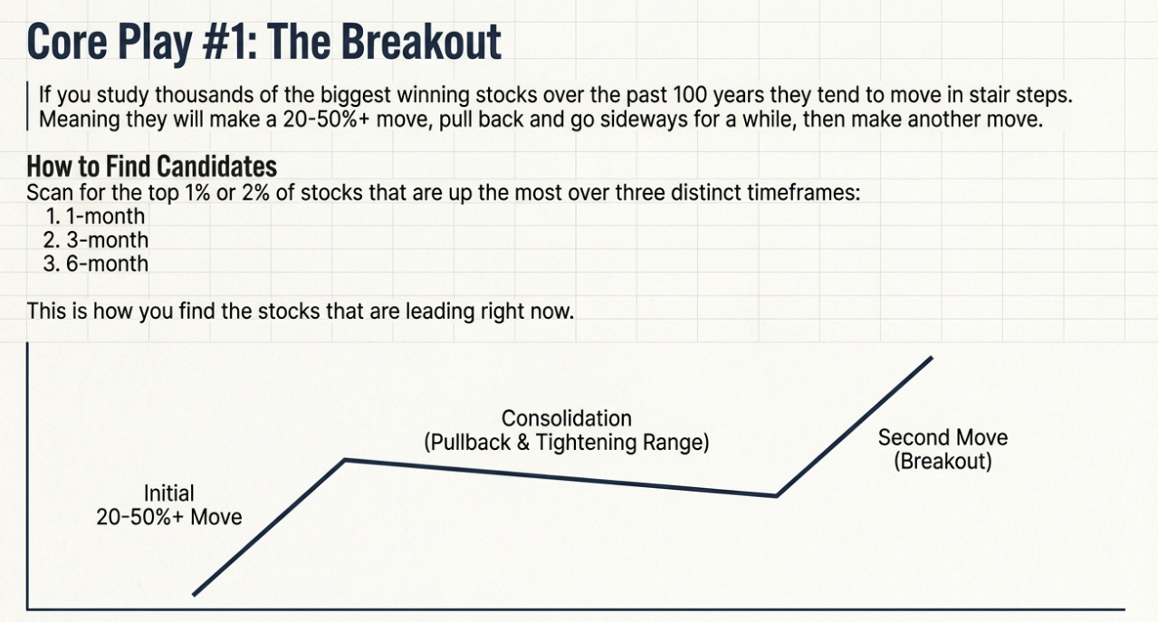

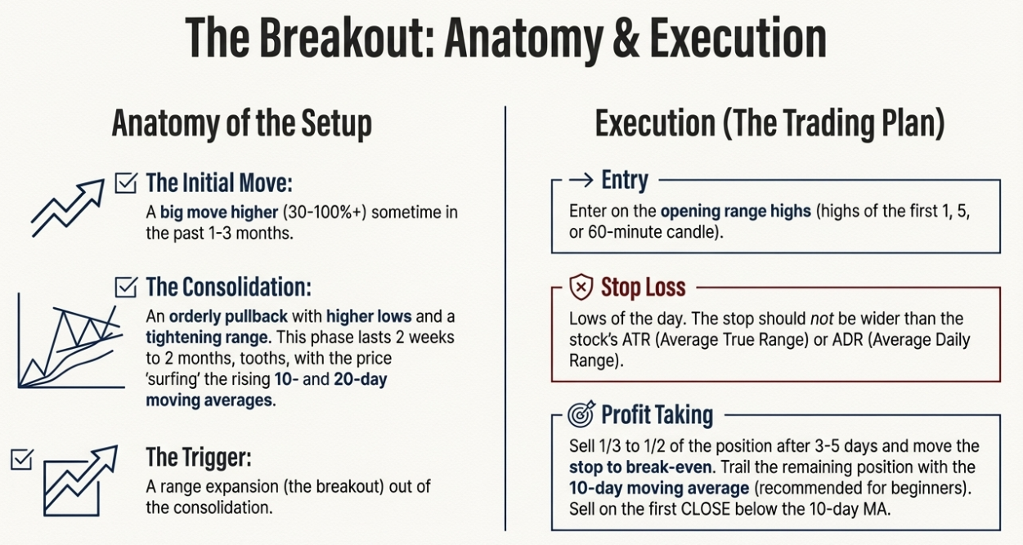

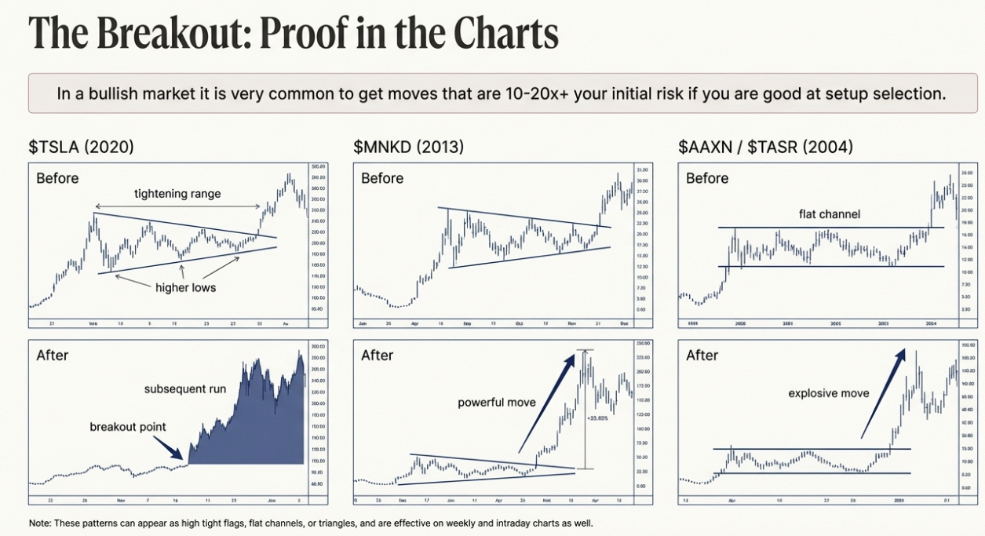

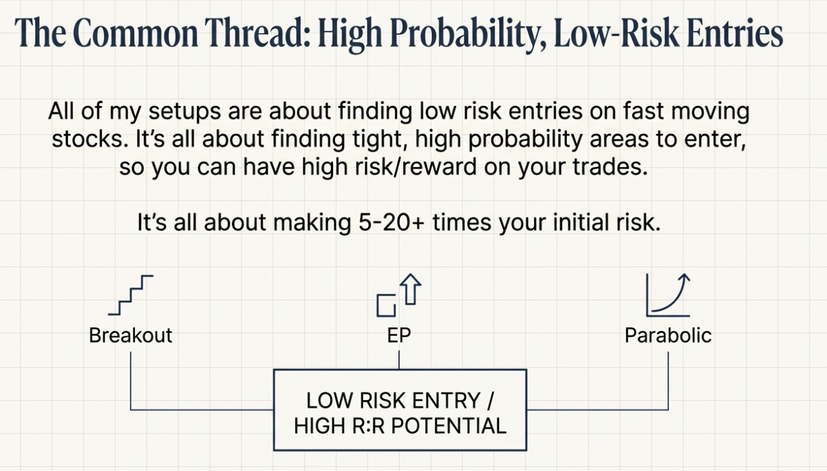

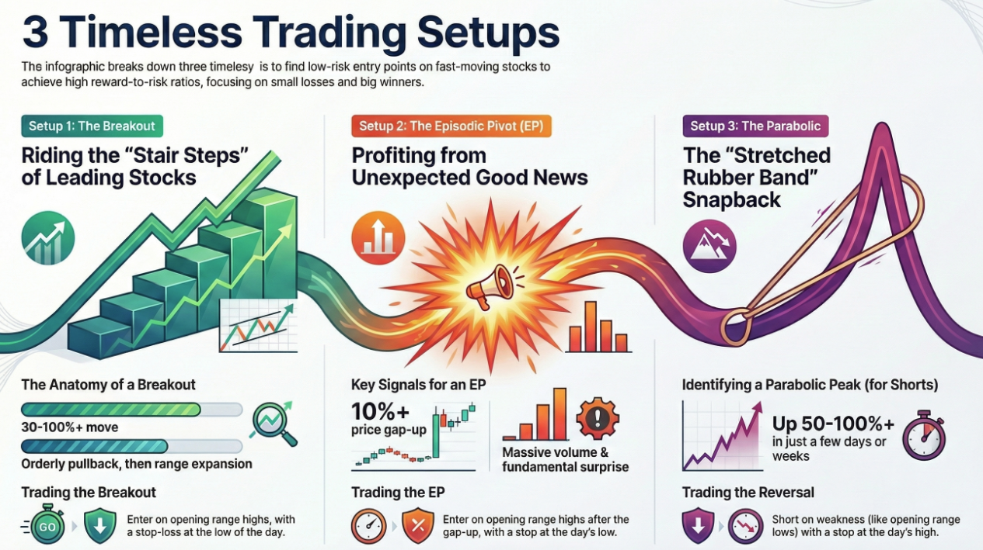

## Metadata

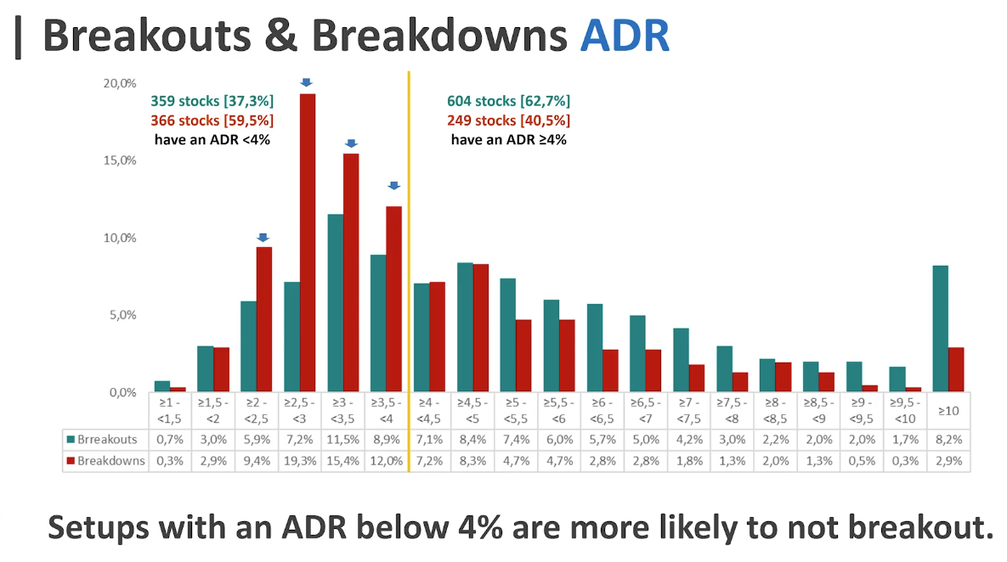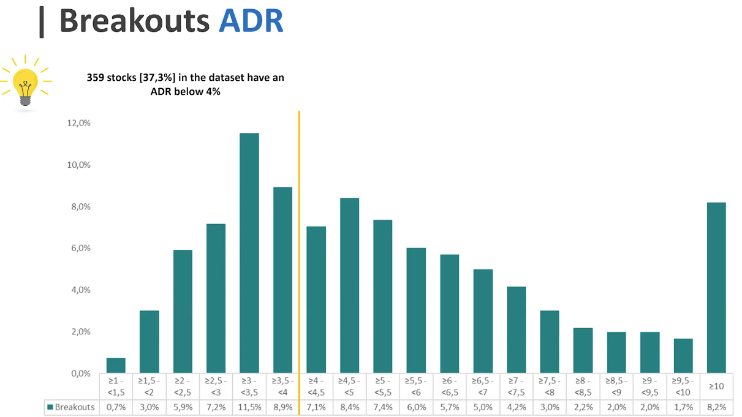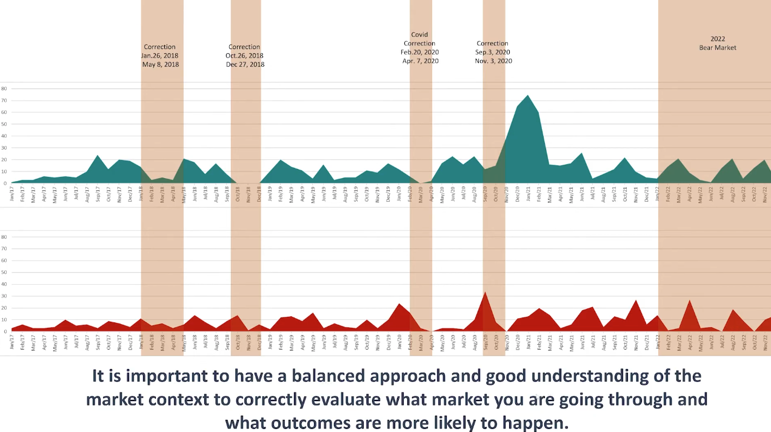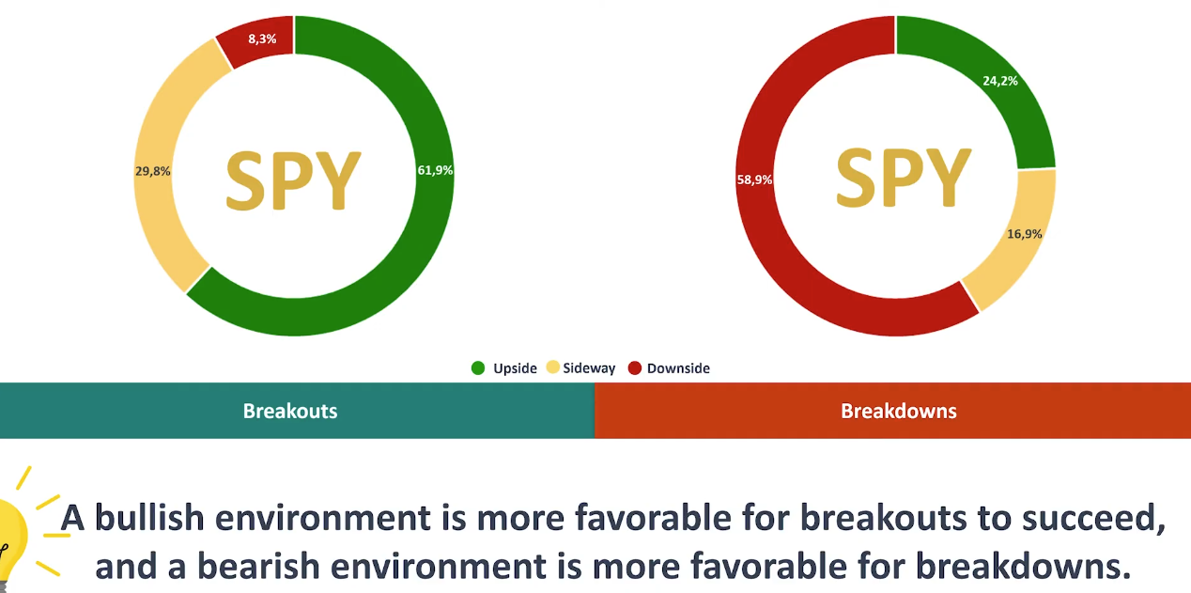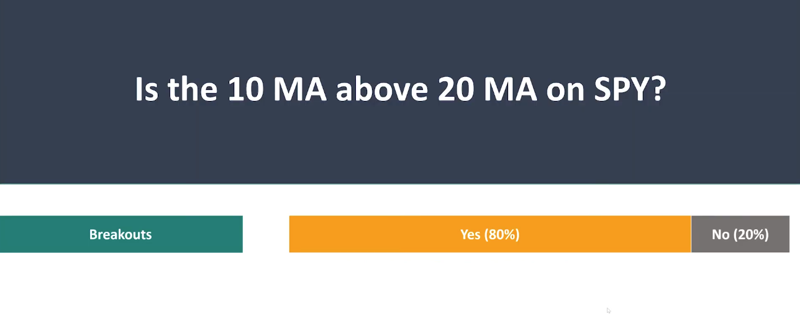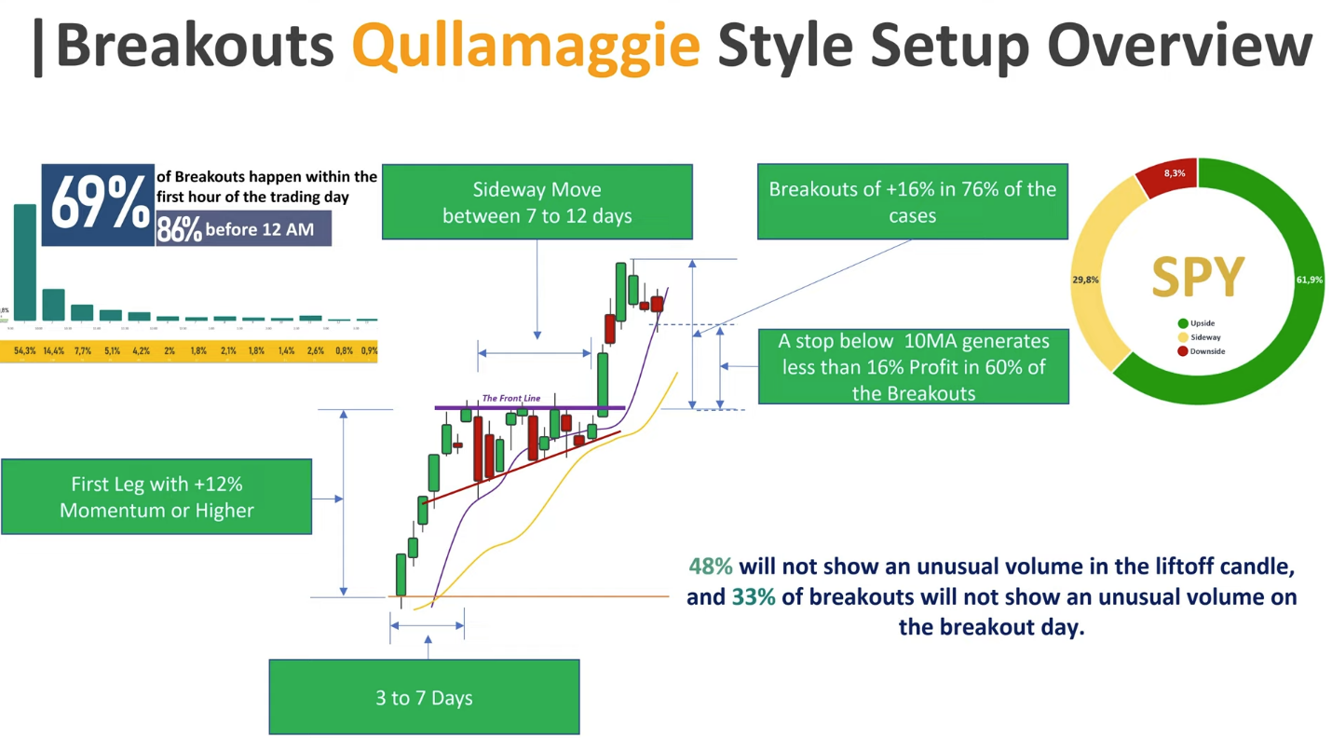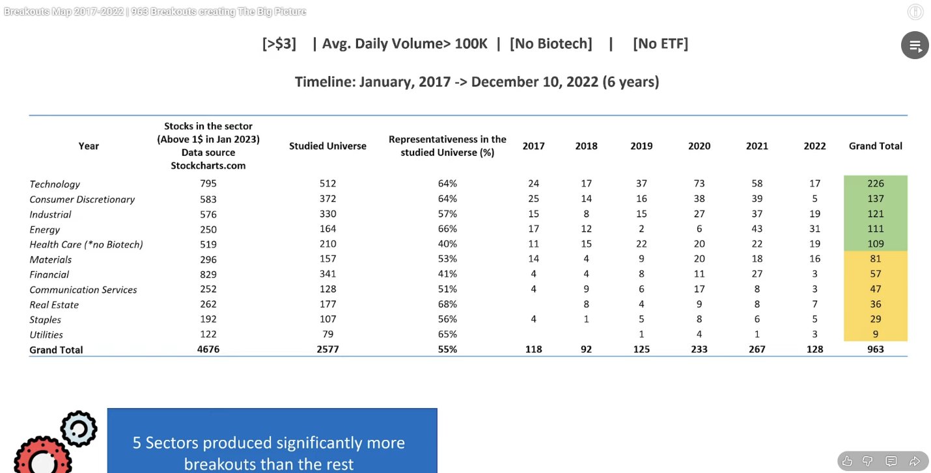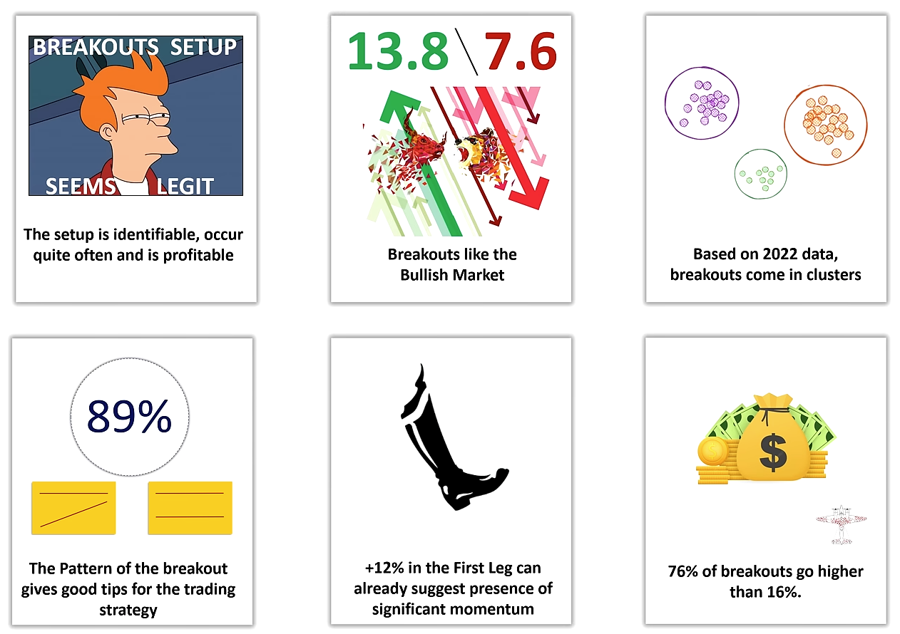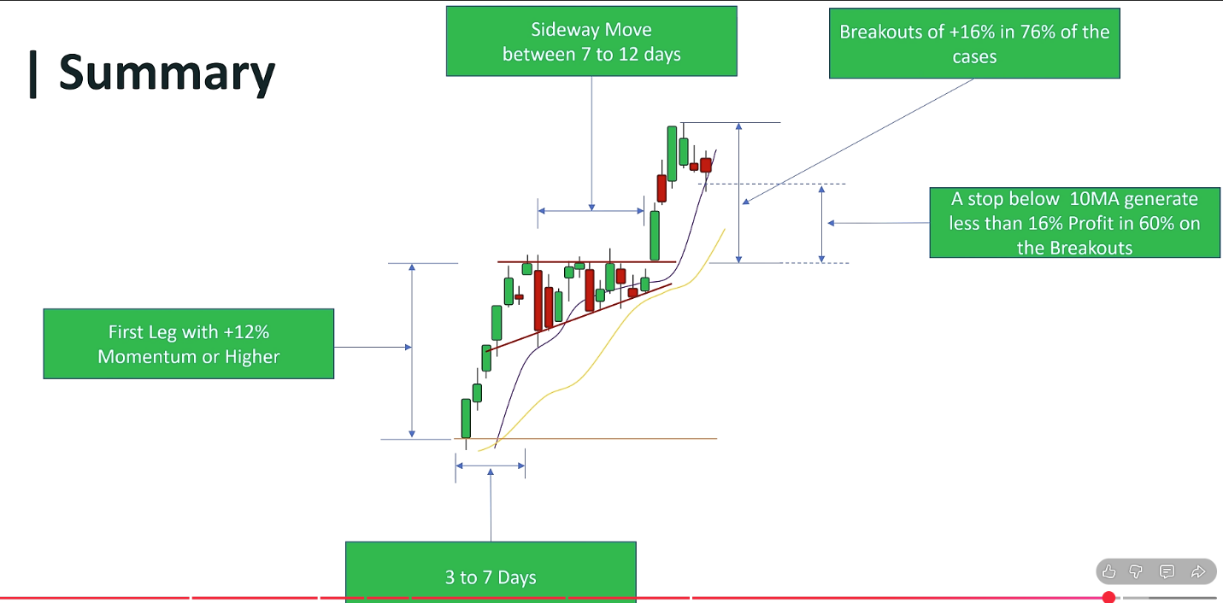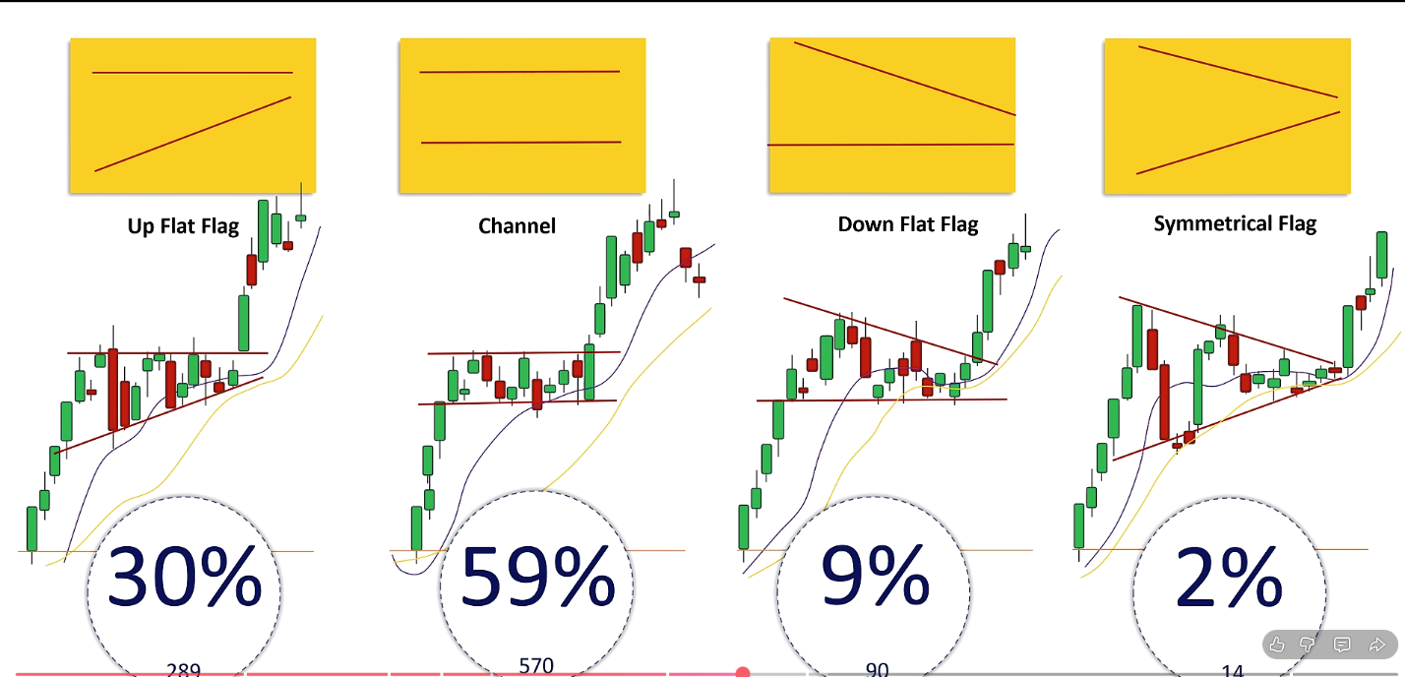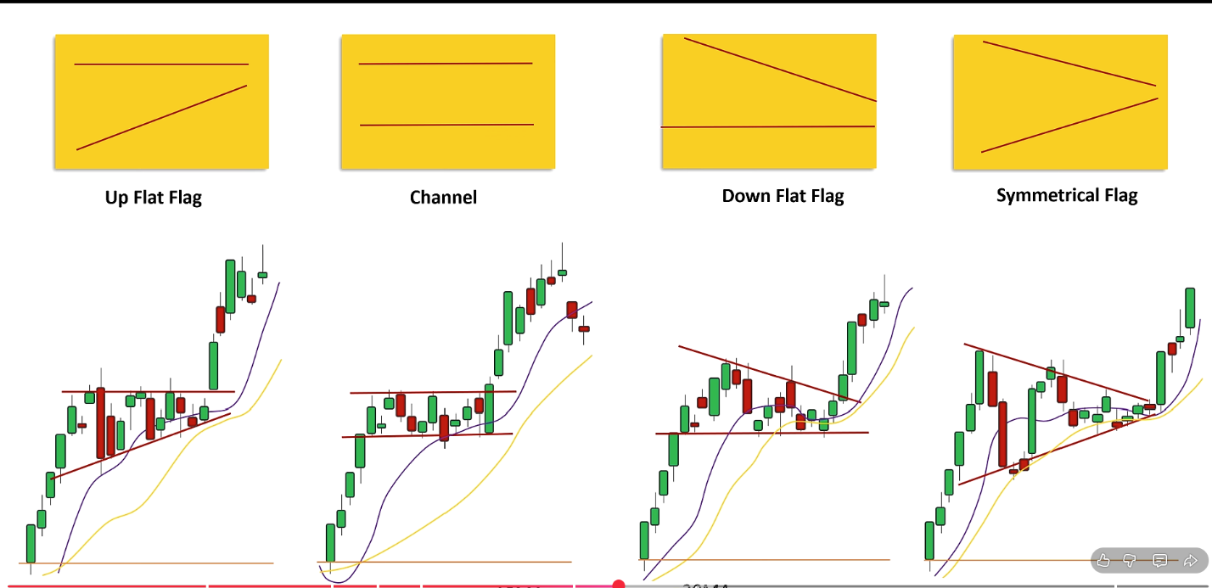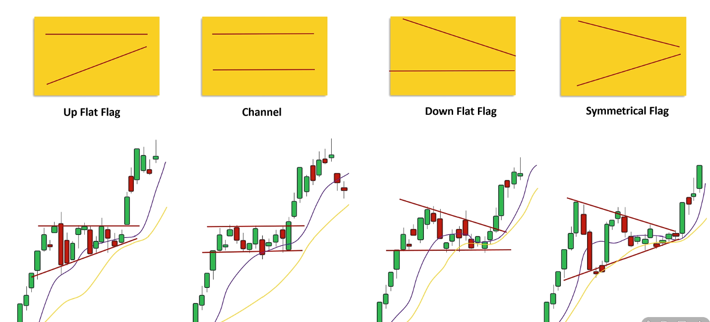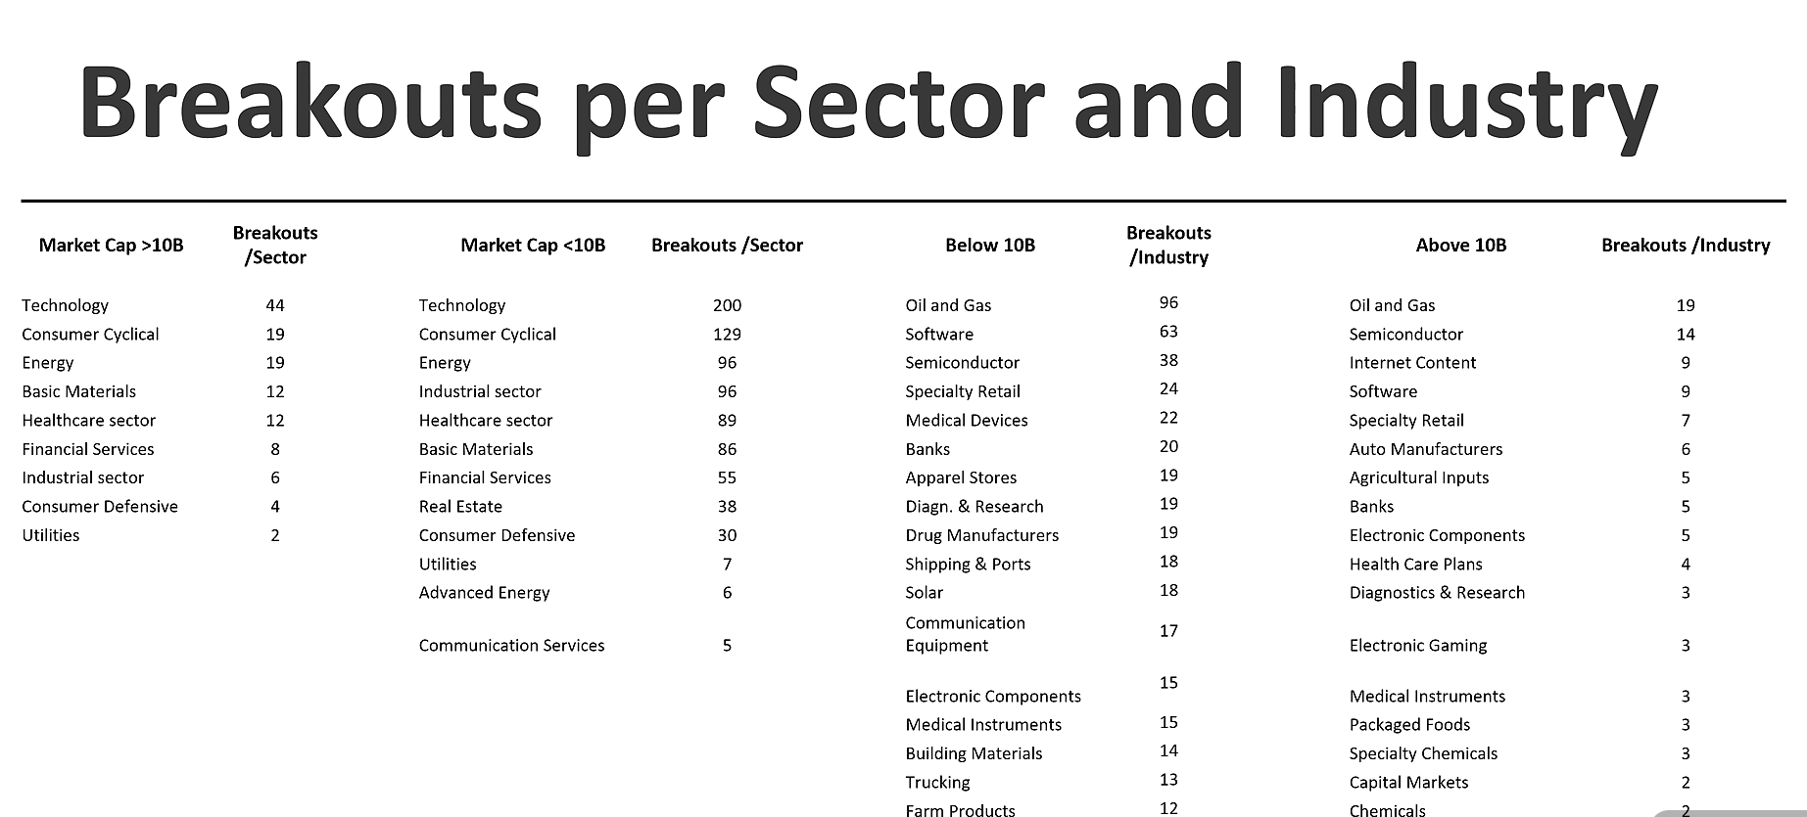

# Oliver Kell

Oliver Kell's Winning Stock Trading Strategy and Tactics

Top of Form

The book, *Victory in Stock Trading Strategy and Tactics of the 2020 U.S. Investing Champion* by Oliver Kell, is a guide detailing the trading approach and strategies that led the author to win the 2020 U.S. Investing Championship with a 941.10% return. Published in 2021, the book aims to share Kell's interpretation of the price cycle and approach to the markets, serving as his "spin" on foundational ideas to speed up the reader's learning curve.

Core Trading Philosophy and Influences

Kell identifies as an **intermediate term trend follower and a swing trader**. His methodology is deeply rooted in the work of **William O’Neil**, the author of *How to Make Money in Stocks*, and he suggests readers study O’Neil's methods first. Other significant influences mentioned are Jesse Livermore, Nicolas Darvas, and Peter Lynch.

A core belief presented in the book is that the individual retail investor can "trounce the 'Gods of Wall Street'" through diligence, commitment, and eagerness to learn. Kell emphasizes that a rules-based strategy combined with the ability to act on intuition and manage risk is the ultimate combination for achieving large returns.

He also draws parallels between trading and military strategy, stemming from an independent study comparing his professor's *Winning at War: 7 Keys to Military Victory Throughout History* to the traits of a perfect trader. The seven traits include Superior Discipline, Superior Technology, The Ability to Protect Capital, and Sustained Ruthlessness.

Tools for Analysis

Kell is a **slave to price** and uses **volume for clues**, utilizing moving averages to ride the trend. The main tools Kell uses for market analysis include:

1. **Price**

2. **Volume**

3. **Moving Averages:** 10 and 20 Period Exponential Moving Averages (EMAs) on all timeframes, and the 50 and 200 Period Simple Moving Averages (SMAs) on the Daily Chart.

4. **Multiple Timeframes:** 5 Minute, 15 Minute, Hourly, Daily, Weekly, and Monthly charts, emphasizing the fractal nature of price action.

5. **Chart Patterns.**

The Cycle of Price Action (Ebb & Flow of the Market)

A central framework detailed in the book is the "Cycle of Price Action," used to think about market trends and prevent chasing stocks. This cycle outlines the steps a stock takes when transitioning between uptrends and downtrends:

|  |  |  |
| --- | --- | --- |
| Market Phase | Trend Steps | Description |
| **Uptrend Cycle** | Reversal Extension → Wedge Pop → EMA Crossback → Base n’ Break → Exhaustion Extension | Describes the transition from bottoming (capitulation) to sustained trending (basing/breaking) and finally topping (euphoria). |
| **Downtrend Cycle** | Exhaustion Extension → Wedge Drop → EMA Crossback → Base n’ Break → Reversal Extension | Describes the transition from topping to sustained downtrends and eventual bottoming. |

Kell notes that the patterns are a guide and framework, not a rigid sequence, and the goal is to combine multiple timeframes to capture a higher timeframe trend while defining risk with a lower timeframe entry.

Stock Selection (Name Selection)

Kell seeks the **strongest growth stocks** with game-changing stories. Key criteria for stock selection include:

• **Relative Strength (RS):** Buying stocks that are holding up better than the underlying index during corrections or outperforming in uptrends. This divergence in strength is a signal to pay attention.

• **Volume:** Looking for "Bull snorts" (heavy volume signatures) as a sign of institutional buying, which smaller investors want to follow.

• **Big Theme:** Stocks driven by a powerful "story" or vision of the future (e.g., EVs, Work from Home, Telehealth) provide the conviction needed to hold through pullbacks.

• **Sales and Earnings Growth:** High sales growth (25% or more annualized) and high earnings growth are indicators of market leaders, aligning with O'Neil's teaching.

• **Liquidity and Beta:** Preference for stocks trading over 1 million shares per day and higher beta stocks, which move quickly in a strong trend. Kell avoids penny stocks (under $10) because institutional sponsorship is desired, and protecting principal capital is paramount.

Risk Management and Portfolio Construction

A crucial aspect of Kell's approach is defense and capital protection.

**Stop Placement and Selling:**

• Stops should be placed at the low of a strong breakout day or an "Ignition Bar low"—if this low is violated, the trade reason is invalid.

• The 10/20 EMA is used as a **trailing stop**.

• When a stock gets extended from the Weekly 10 EMA, booking partial or full profits is prudent, as the odds of consolidation increase.

• The concept of **"Sell Some, Hold Some"** is utilized to book profits when gains are a multiple of risk (e.g., 5x risk), helping to maintain a core position for larger moves.

**Avoiding Bad Markets:**

• When the index representing growth stocks (NASDAQ Composite or QQQ ETF) is **below the 20 EMA, the trader should be cautious, raise cash, or be extremely selective**.

• Kell is much less aggressive with shorting stocks, finding it more difficult than trading the long side.

• He emphasizes uncovering the next big winners during corrections by finding stocks exhibiting relative strength.

**Position Sizing:**

• Kell typically holds **8–12 names**, often trading with margin.

• He advocates a **top-weighted portfolio**, giving the highest percentage allocation (25-35%) to his 2-3 "Top Ideas" which are near the beginning of their trend and breaking out of large bases.

• He manages risk by **buying and selling in pieces**, tightening stops as position size increases, aiming to use initial profits to increase size while reducing the principal capital at risk.

The goal of this aggressive strategy is compounding returns to achieve gains that drastically outperform index funds, aiming for returns of hundreds of percent annually.

Bottom of Form

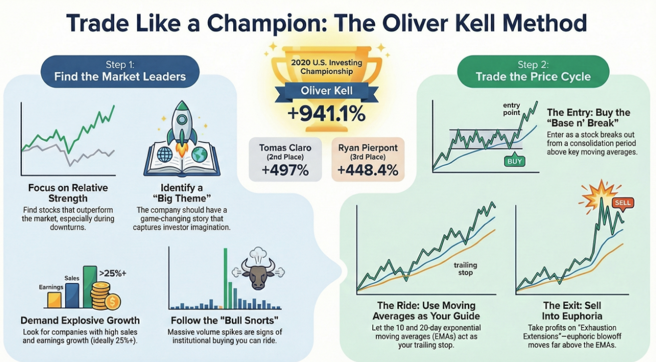

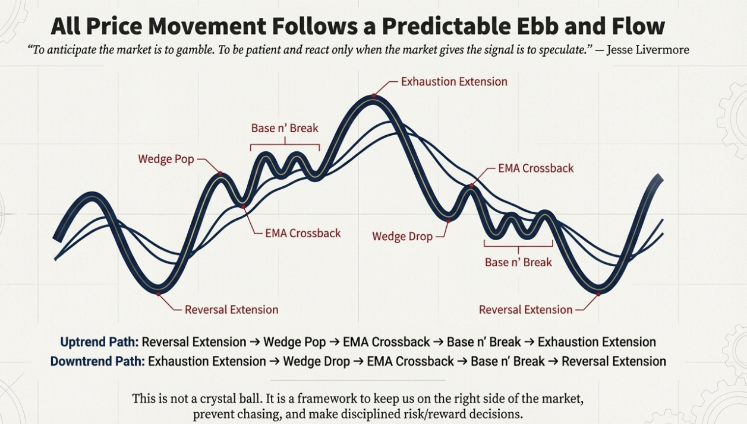

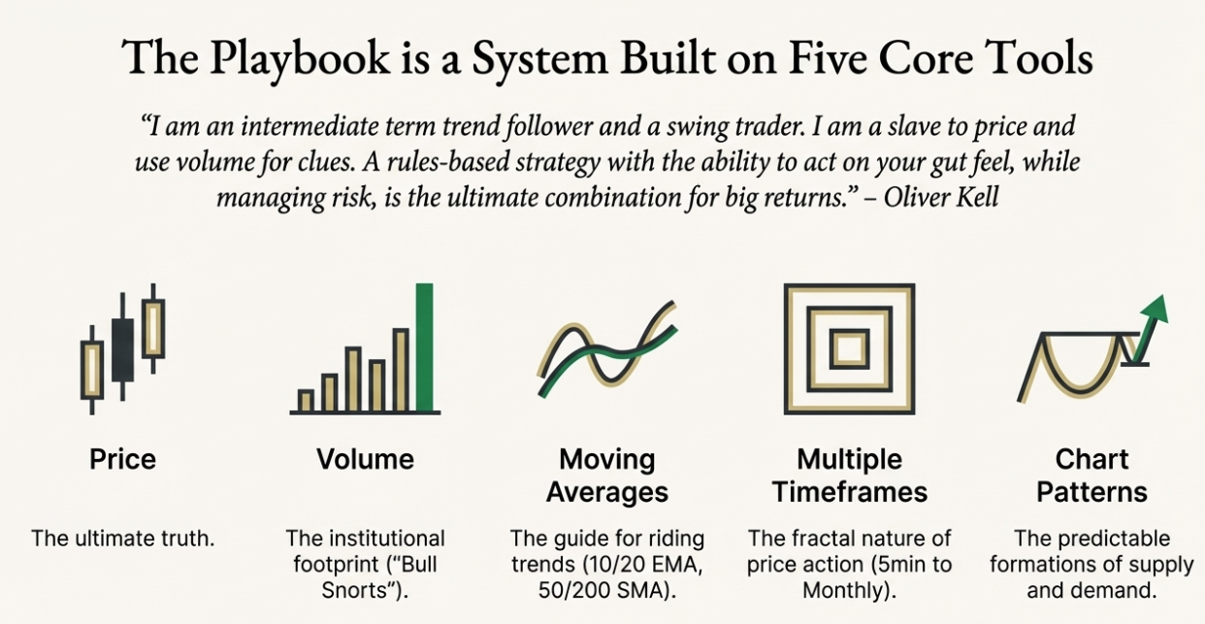

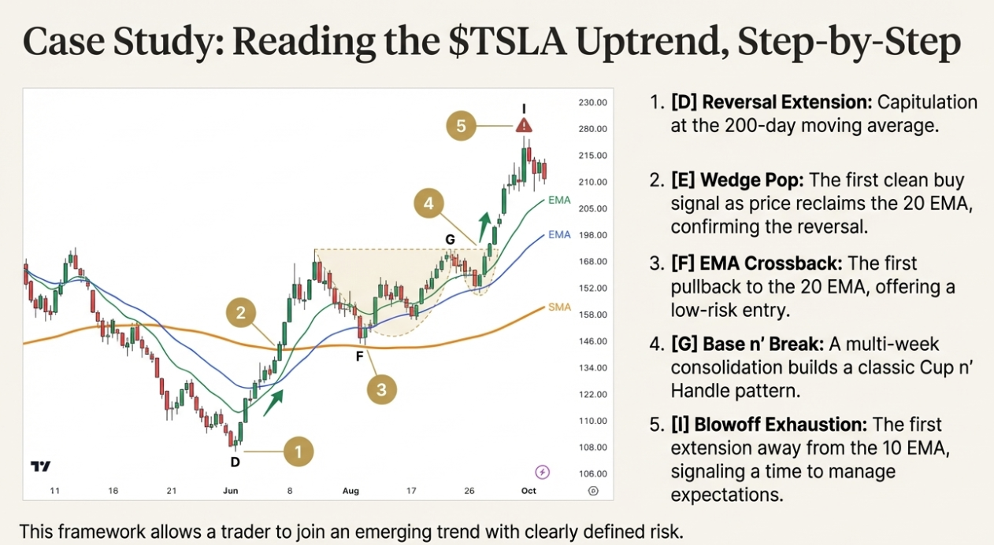

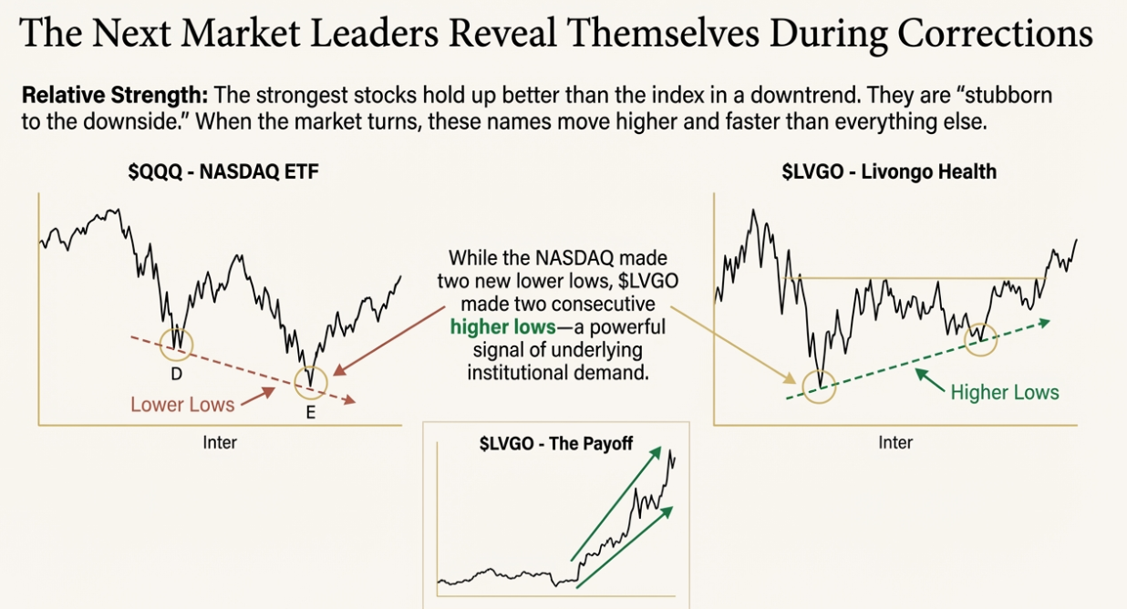  
  
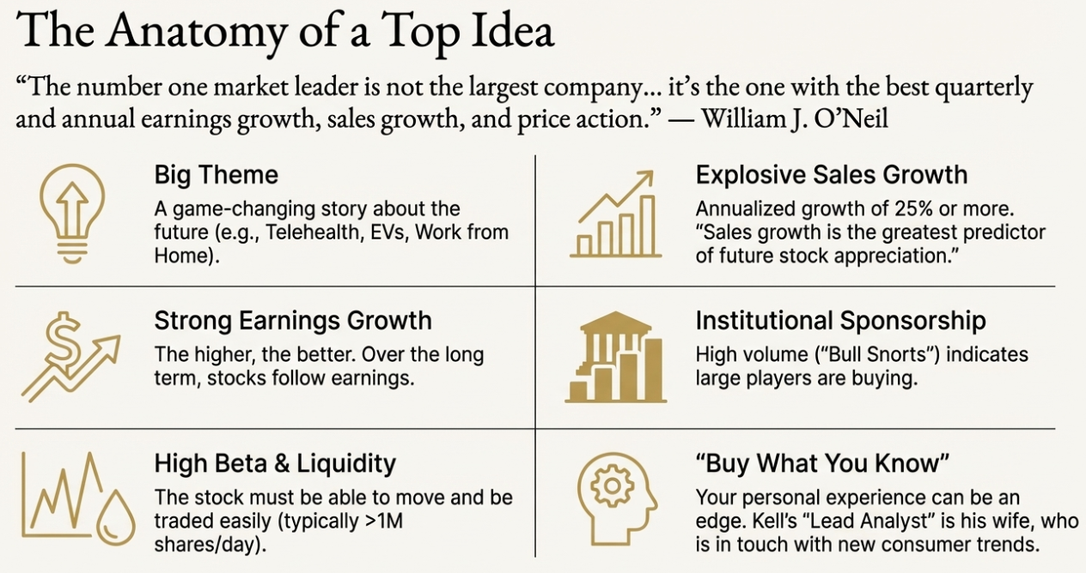

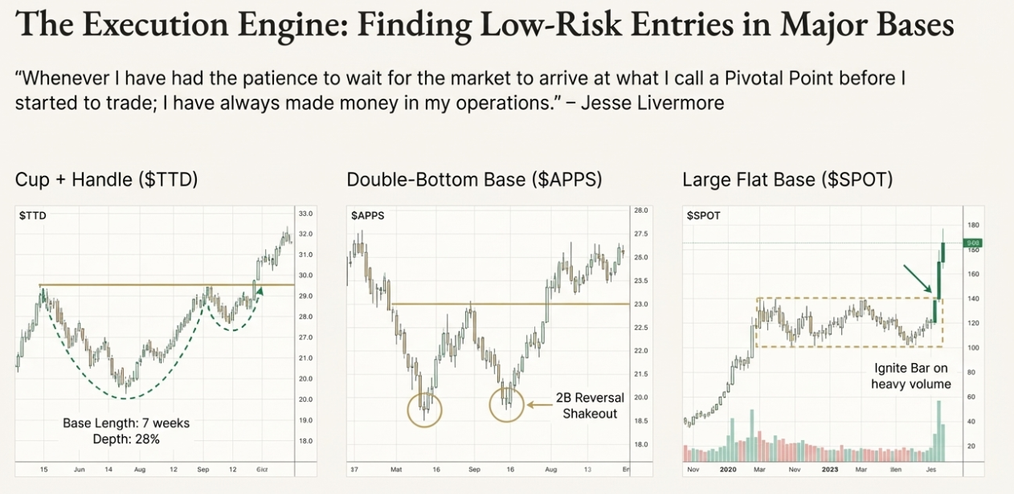

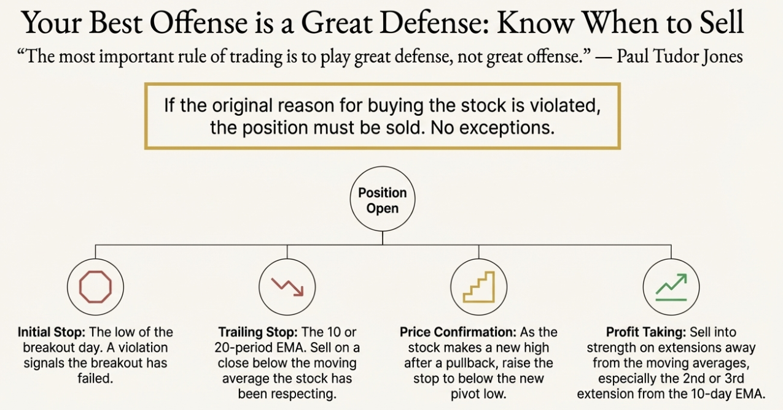

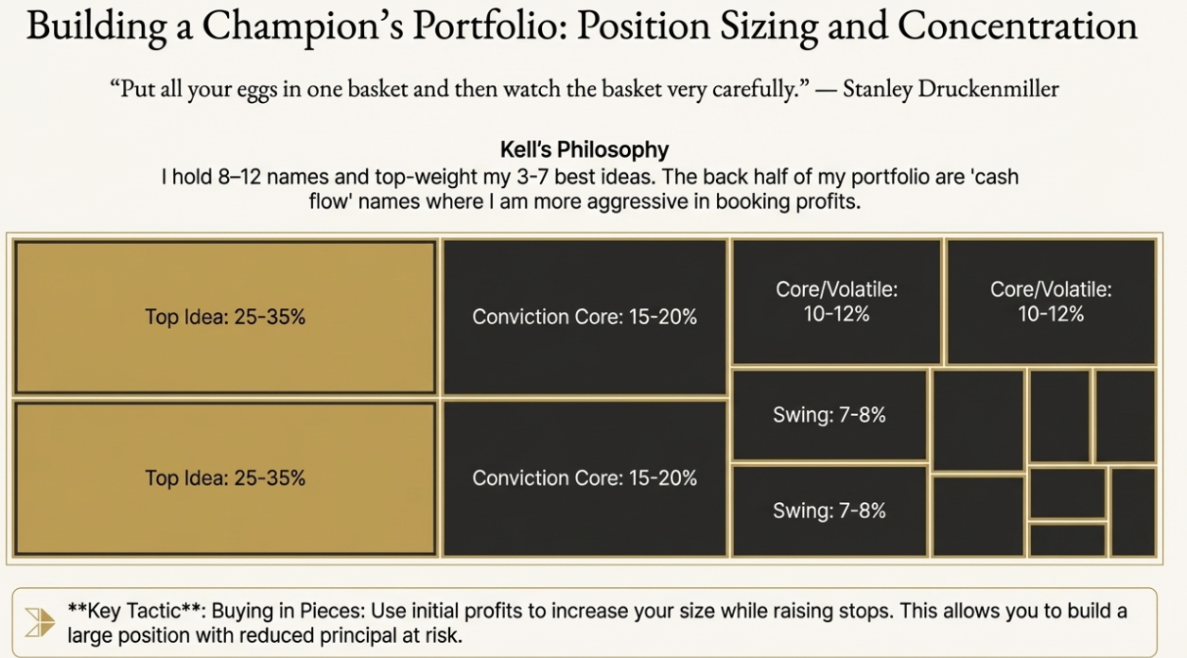

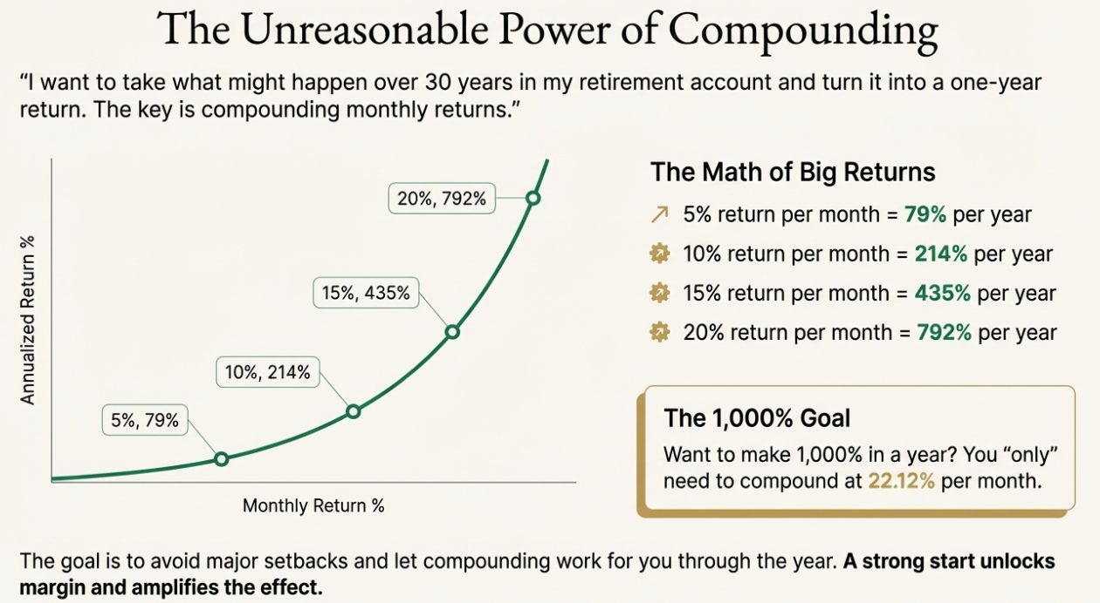  
  
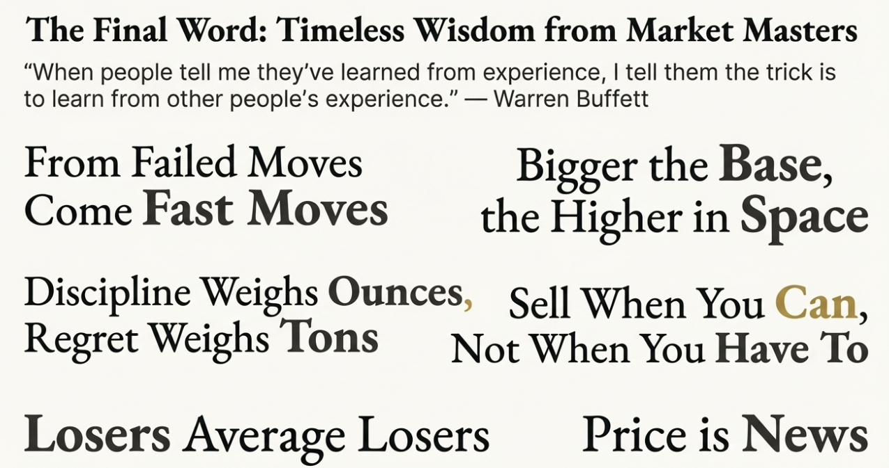

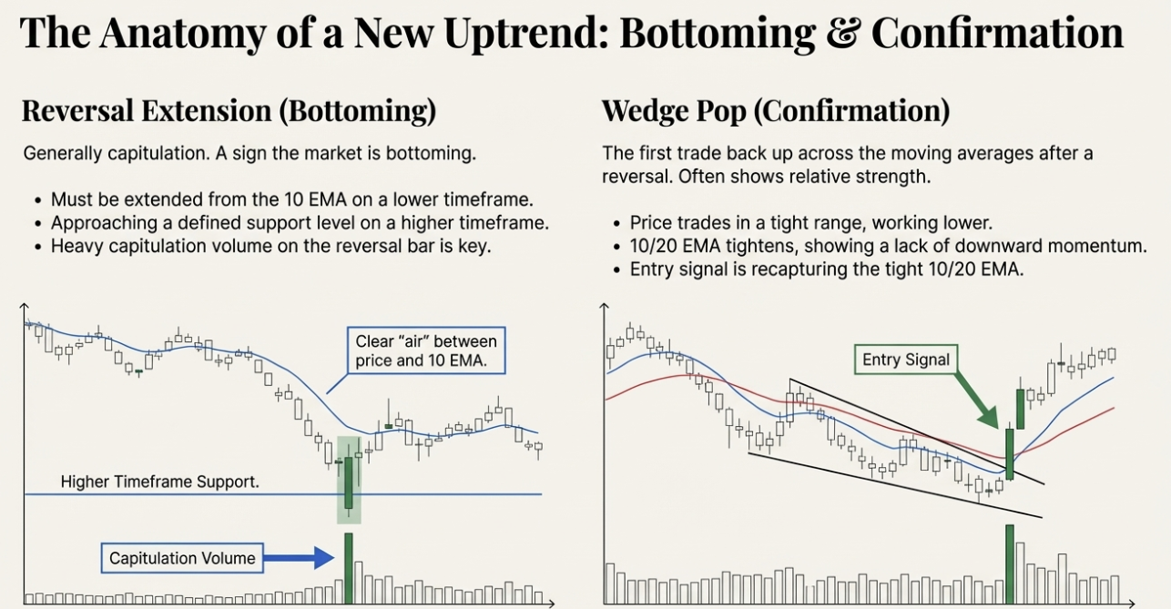

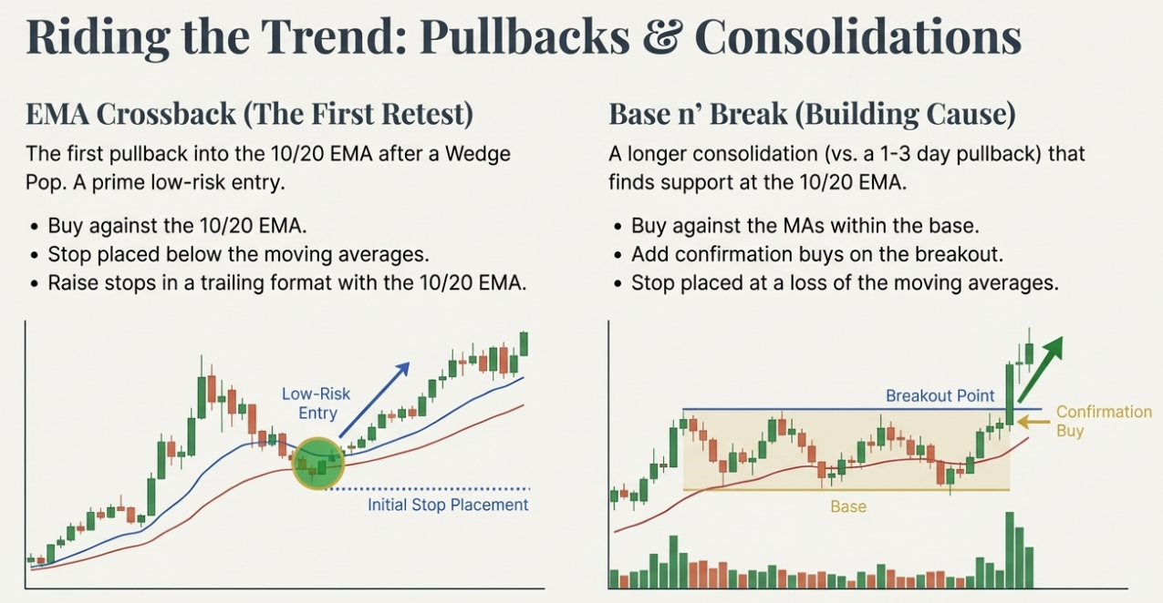

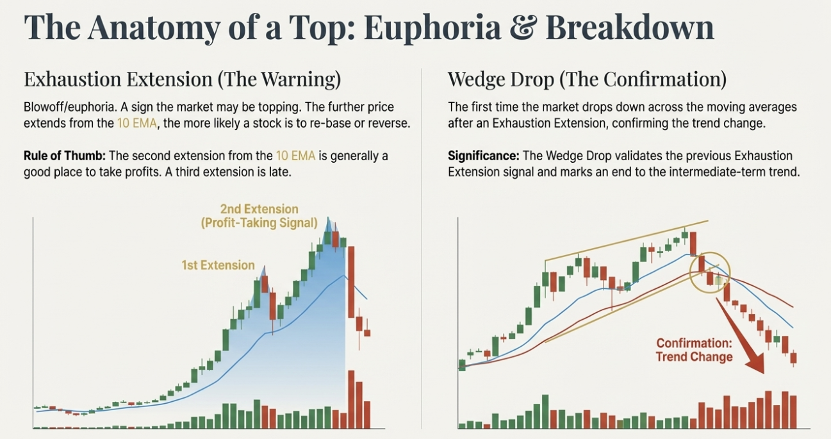

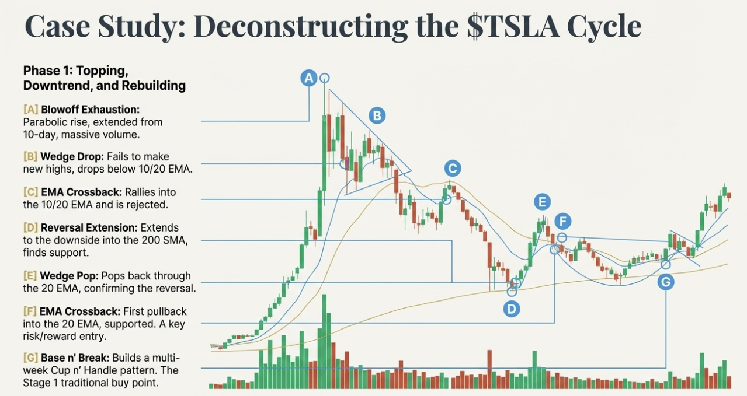  
  
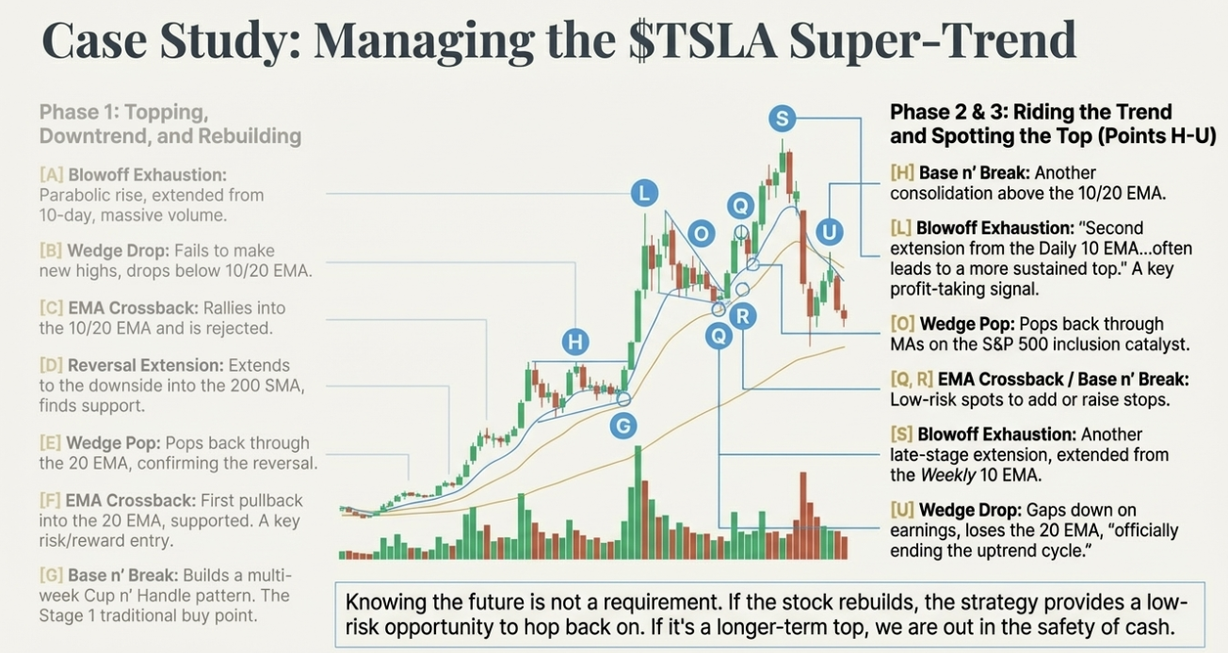

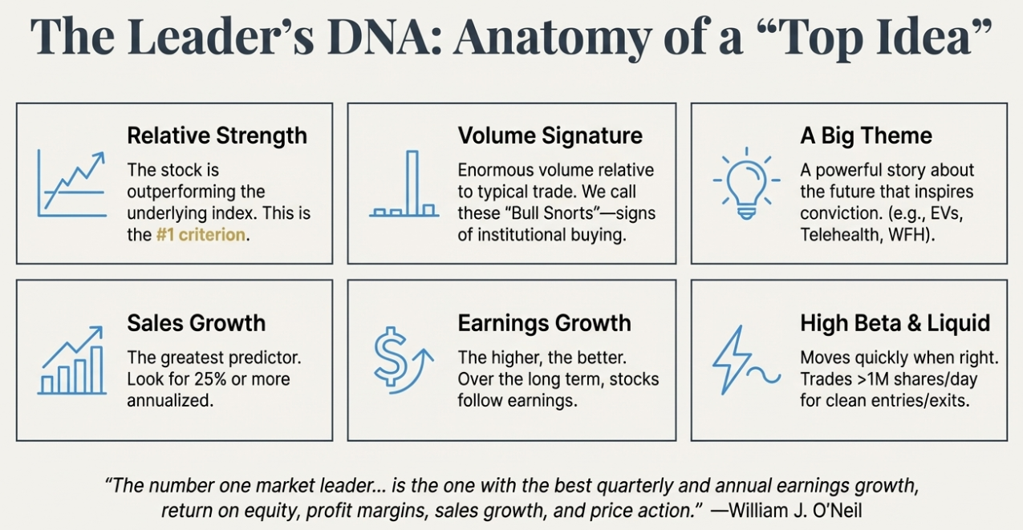

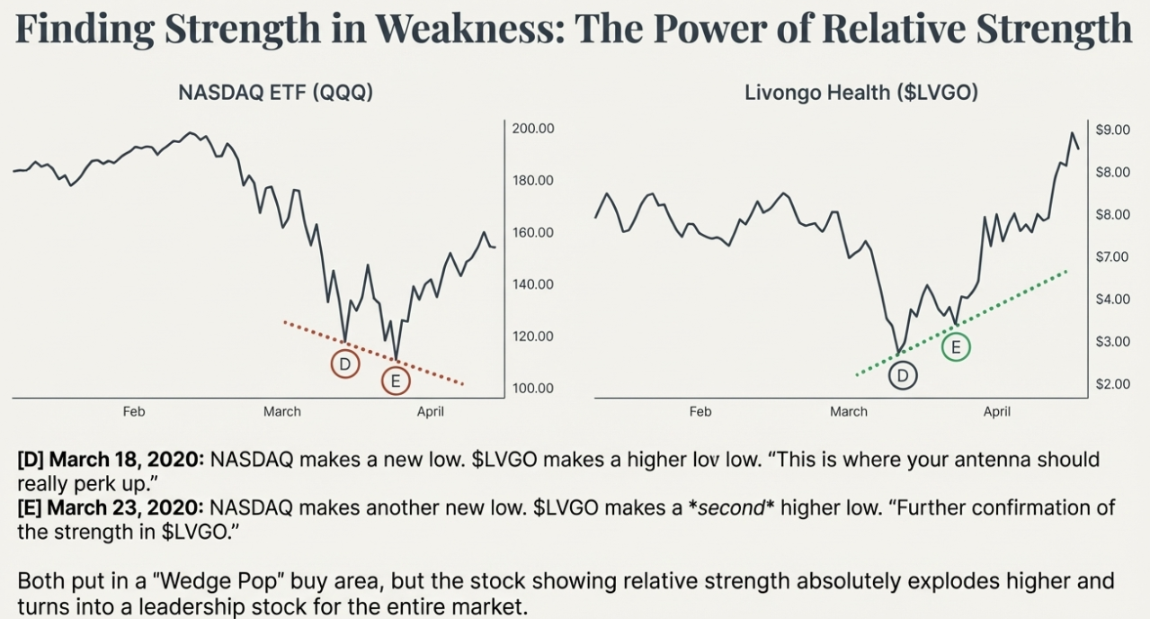

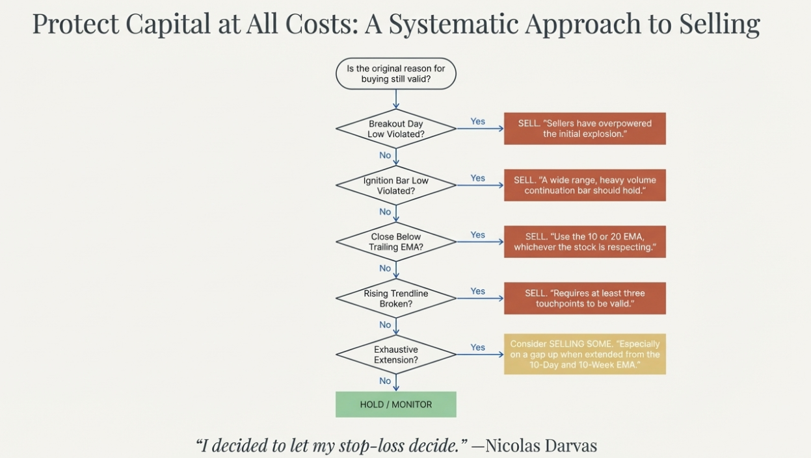

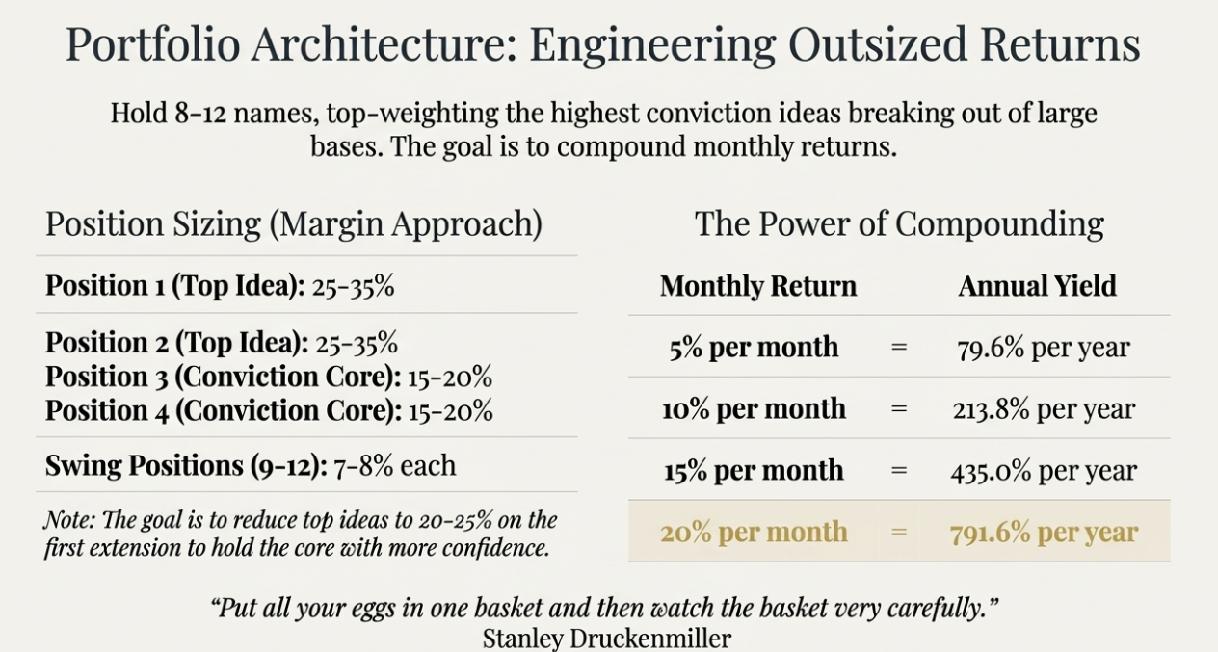

# O’Neil

